Homework 2： Order application

For this case study, you’ll create an application that allows the user to place an order at a fictitious coffee shop named Tuxedo Cat Coffee. Prerequisites: Chapters 1 to 8.

## User interface

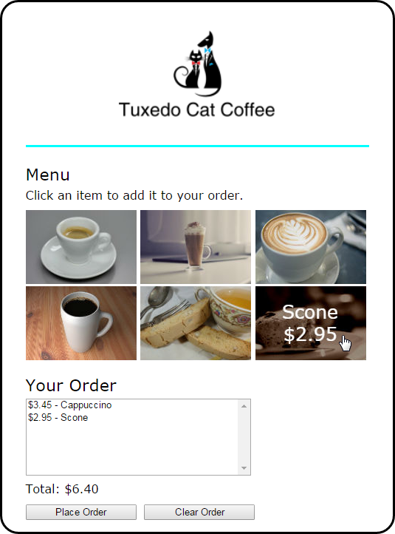

## Specifications

* When the user hovers the mouse over one of the images in the menu, another image should be displayed with the description and price of the item. The id attribute of each image identifies the image to be displayed when it’s rolled over.

当用户将鼠标悬停在菜单中的一个图像上时，另一个图像将显示该项目的描述和价格。每个图像的id属性标识在翻转时要显示的图像。

* The rollover images should be preloaded.

滚动图像应该预先加载。

* When the user clicks on an image, the order list and order total should be updated and displayed.

当用户单击一个图像时，应该更新并显示订单列表和订单总数。

* If the user clicks the Place Order button, the checkout.html page should be displayed.

如果用户单击Place Order按钮，就会显示checkout.html页面。

* If the user clicks the Clear Order button, all of the items should be removed from the order list and the total should be cleared.

如果用户单击清除订单按钮，则应从订单列表中删除所有项目，并清除总数。